Name: Krishnaprasad Awala

Roll no: D2215004

Enroll no: MITU21BTITD006

Batch: Core-2

AI LAB Assignment 2 : TensorFlow

import tensorflow as tf

from sklearn.datasets import make_circles import pandas as pd

import matplotlib.pyplot as plt

print(tf. version )

2.12.0

#make 1000 examples

n_samples = 1000

#create circles

X,y = make_circles(n_samples,

noise = 0.03,

random_state=42)

# check out the features X

|  |  |
| --- | --- |
| array([[ 0.75424625, | 0.23148074], |
| [-0.75615888, | 0.15325888], |
| [-0.81539193,  ..., | 0.17328203], |

[-0.13690036, -0.81001183],

[ 0.67036156, -0.76750154],

[ 0.28105665, 0.96382443]])

3 # see the first 10 lables y[:10]

array([1, 1, 1, 1, 0, 1, 1, 1, 1, 0])

#Make dataframes of feature and labels

circles = pd.DataFrame({"X0":X[:,0], "X1":X[:,1],"label":y }) circles.head()

# check out the different lables circles.label.value_counts()

1 500

0 500

Name: label, dtype: int64

# visualize with a plot

plt.scatter(X[:,0],X[:,1],c=y,cmap=plt.cm.RdYlBu);

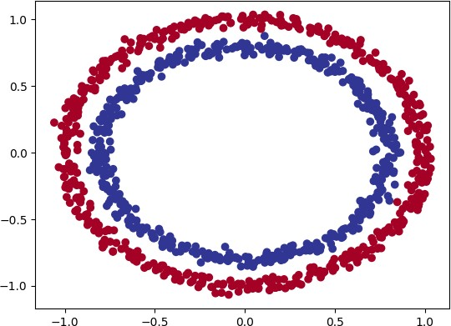

tf.random.set_seed(42)

# 1. Create the model using the sequential API model_1 = tf.keras.Sequential([

tf.keras.layers.Dense(1)

])

#2 .Compile the model

model_1.compile(loss=tf.keras.losses.BinaryCrossentropy(), optimizer=tf.keras.optimizers.SGD(),

metrics=['accuracy']

)

# 3 fit the model

model_1.fit(X,y,epochs=5)

# 1. Create the model using the sequential API model_2 = tf.keras.Sequential([

tf.keras.layers.Dense(10)

])

#2 .Compile the model

model_2.compile(loss=tf.keras.losses.BinaryCrossentropy(), optimizer=tf.keras.optimizers.SGD(),

metrics=['accuracy']

)

# 3 fit the model

model_2.fit(X,y,epochs=5)

 Epoch 1/5

32/32 [==============================] - 1s 2ms/step - loss: 4.0263 - accuracy: 0.4730

Epoch 2/5

32/32 [==============================] - 0s 2ms/step - loss: 0.9109 - accuracy: 0.4900

Epoch 3/5

32/32 [==============================] - 0s 2ms/step - loss: 0.7149 - accuracy: 0.4870

Epoch 4/5

32/32 [==============================] - 0s 2ms/step - loss: 0.7003 - accuracy: 0.4940

Epoch 5/5

32/32 [==============================] - 0s 2ms/step - loss: 0.6963 - accuracy: 0.4990

Epoch 1/5

32/32 [==============================] - 1s 3ms/step - loss: 4.0846 - accuracy: 0.1030

Epoch 2/5

32/32 [==============================] - 0s 3ms/step - loss: 3.7597 - accuracy: 0.0430

Epoch 3/5

32/32 [==============================] - 0s 2ms/step - loss: 3.4218 - accuracy: 0.0560

Epoch 4/5

32/32 [==============================] - 0s 2ms/step - loss: 3.1113 - accuracy: 0.1110

Epoch 5/5

32/32 [==============================] - 0s 2ms/step - loss: 3.0286 - accuracy: 0.0830

<keras.callbacks.History at 0x7fa1e848baf0>

[Colab paid products](https://colab.research.google.com/signup?utm_source=footer&utm_medium=link&utm_campaign=footer_links) - [Cancel contracts here](https://colab.research.google.com/cancel-subscription)



2s completed at 18:07